<https://trailhead.salesforce.com/en/content/learn/trails/build-a-travel-approval-app>

Build a Travel Approval App

**Steps:**

1. Create a new App

Setup > App Manager

New Lightning App

Minimum Requirements:

Provide a name

Select the Tabs that you want displayed:

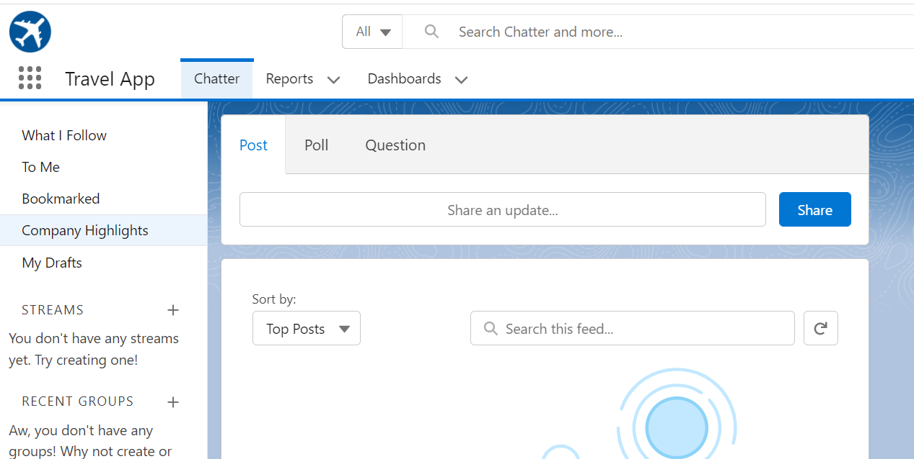

Choose the User Profiles that can access it

1. Create a Custom object

Setup > Object Manager

Create > Custom Object

Provide nName and Plural Name

You should also select these:

Allow Reports

Allow Search

Launch New Custom Tab Wizard after saving this custom object

Choose the Tab Style

Note: This is an example where the key is an auto-generated number:

Note that the TA in front will prepend TA- to the number

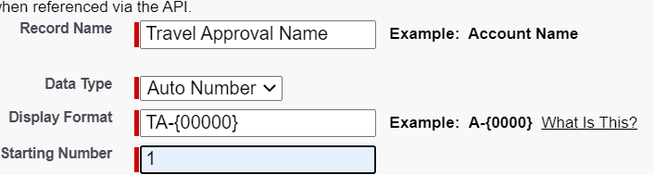  
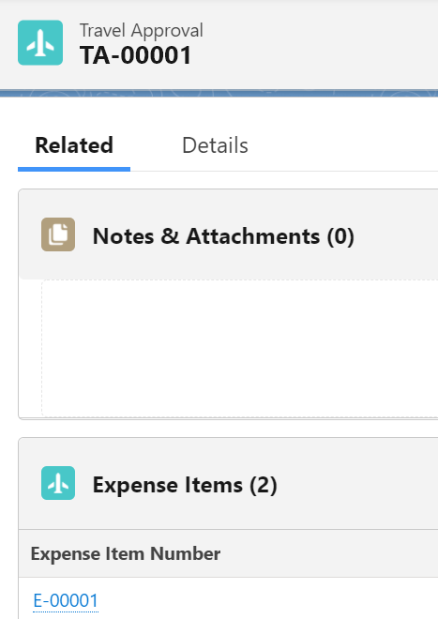

If the object will be a child of another object use ‘Mater-Detail Relationship’ as the datatype for the field that will join to the parent object, then choose the parent object name in the ‘Related To’ dropdown

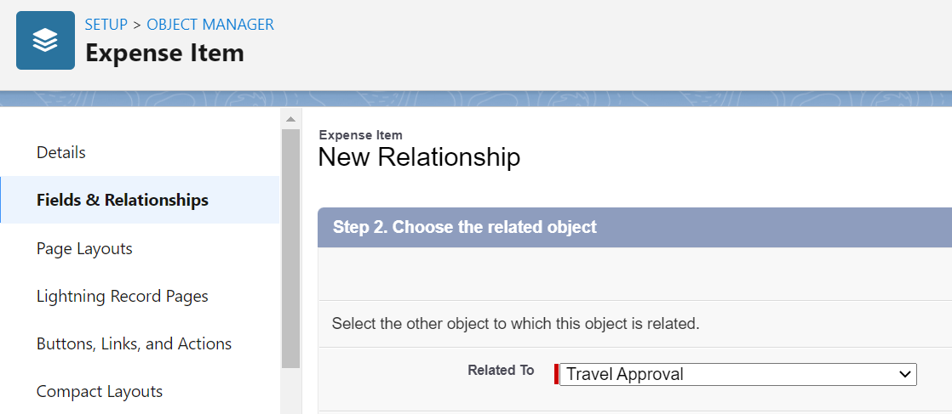

* You can also create a Roll up Summary field that will display a sum from the child elements
* Upload a static file (image
  + Setup > Search for Static, select ‘Static Resources
  + You can upload a zip file that contains multiple images
* Formula Fields (ie display an image based on status)
  + 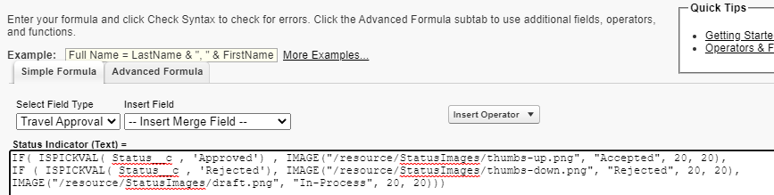

1. Add Users. Specify Managers or Approvers for Users as desired

Extra Stuff:

* If you are in an Object ad you click the Setup (Gear) icon, you will see additional menu options to Edit that Object. It will open the definition of the object in Object Manager (not a specific instance)

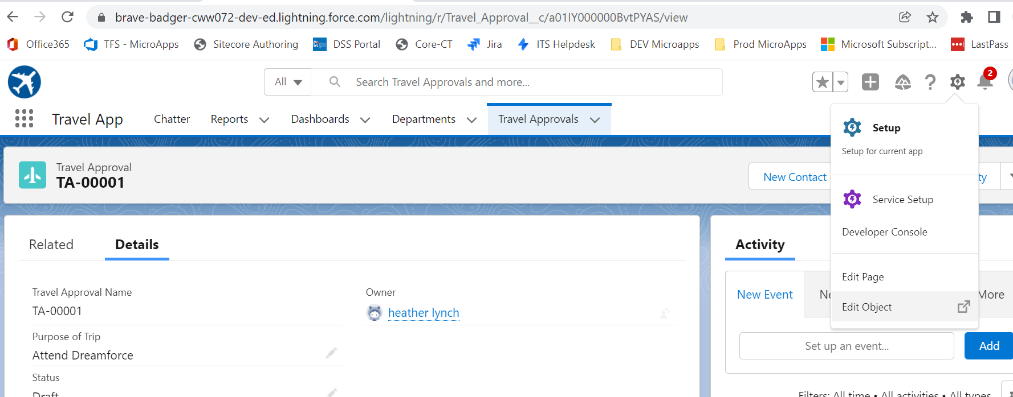

* List view is a set of predefined search filters

For example: Contacts with VIP flags

Setup > Object Manager

Open the object

Search Layouts

Click the dropdown next to Default Layout and select Edit

OR:

Create a personal List View (with a specific filter)

Open the object (not object manager)

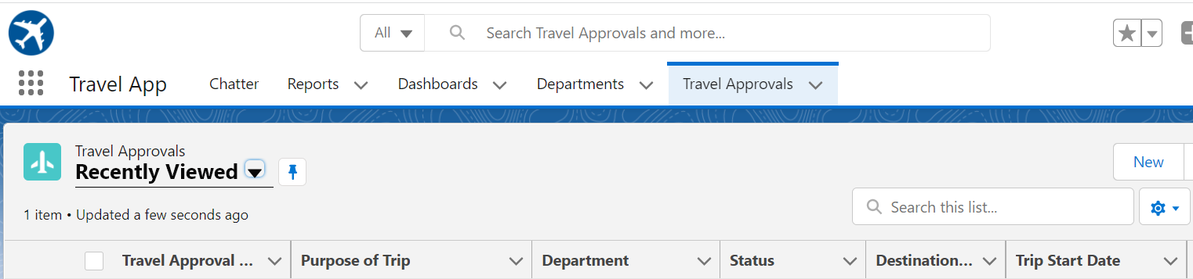

Click on the Gear (far right above pic)

New

Create the List view, then add filters

* [Salesforce Help: Create or Clone a List View in Lightning Experience](https://help.salesforce.com/HTViewHelpDoc?id=customviews_lex.htm&language=en_US)
* [Salesforce Help: Edit List View Filters in Lightning Experience](https://help.salesforce.com/HTViewHelpDoc?id=customviews_edit_filters_lex.htm&language=en_US)
* [Salesforce Help: Create a List View Chart in Lightning Experience](https://help.salesforce.com/HTViewHelpDoc?id=customviews_listview_chart_create_lex.htm&language=en_US)
* [Salesforce Help: Update Records Inline from a List View in Lightning Experience](https://help.salesforce.com/HTViewHelpDoc?id=customviews_edit_inline_listview_lex.htm&language=en_US)

# Change the Page Layout

* You can access the Layout by opening the Tab that you want to change, select Setup > Edit Page

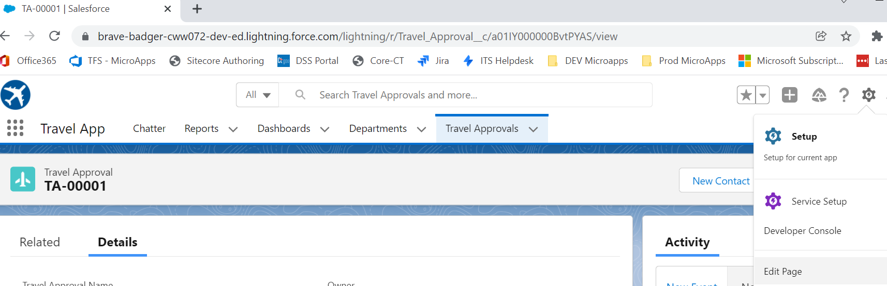

* Or Object Manager > [select the Object ]> Page Layouts

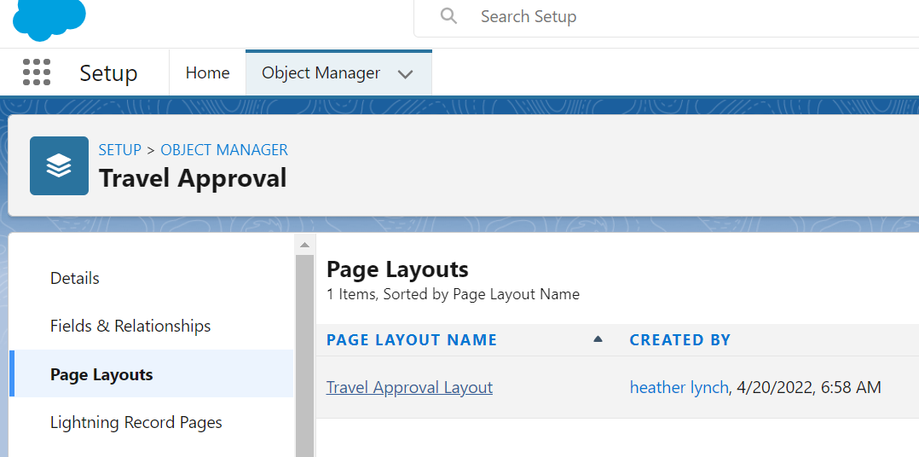

* Click the Layout (see right side)

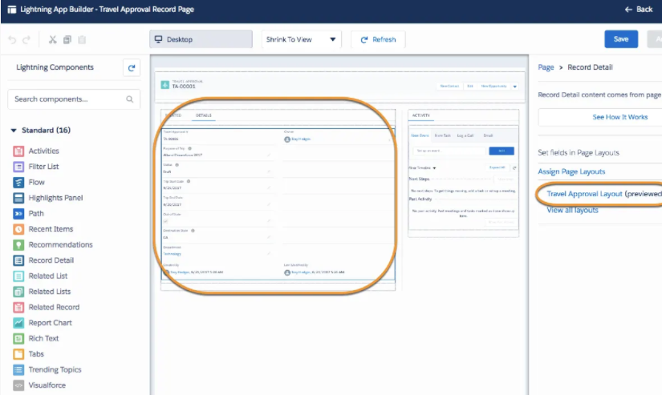

* Validation Rules

On the Object in Object Manager

NOTE: Describe the Error Condition, not the valid condition (when true the error will display)

* xx

# Flow

Salesforce Flow – the product that encompasses building, managing and running flows and processes

Includes Flow builder and others

Flow Builder – point and click tool for building flows

Flow – an app that automates a business process by collecting data and doing something with it

Flow Building Blocks:

Elements – things you drag onto the canvas from the toolbox

Connectors – define the path (which element to execute next)

Resources – Containers that represent a value (field value, formula) that can be referenced through the flow

To create a Flow:

* Setup > Flows (under Process Automation)
* Flow Types:

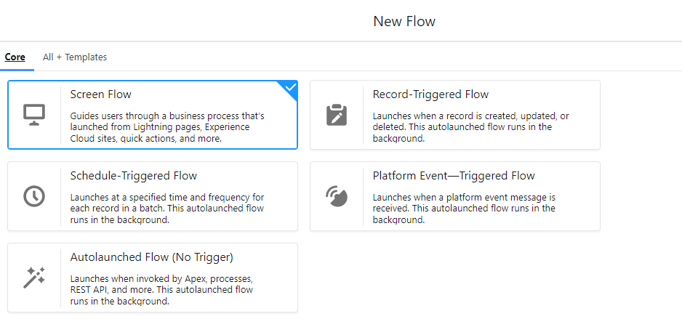

* This is a Record-Triggered Flow, triggered when a Travel Approval record is created or updated. The Layout type was changed to Freeform

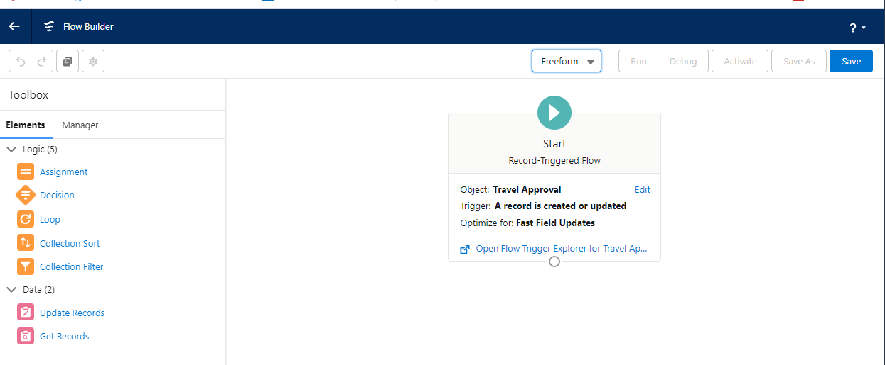

* Example of a Decision

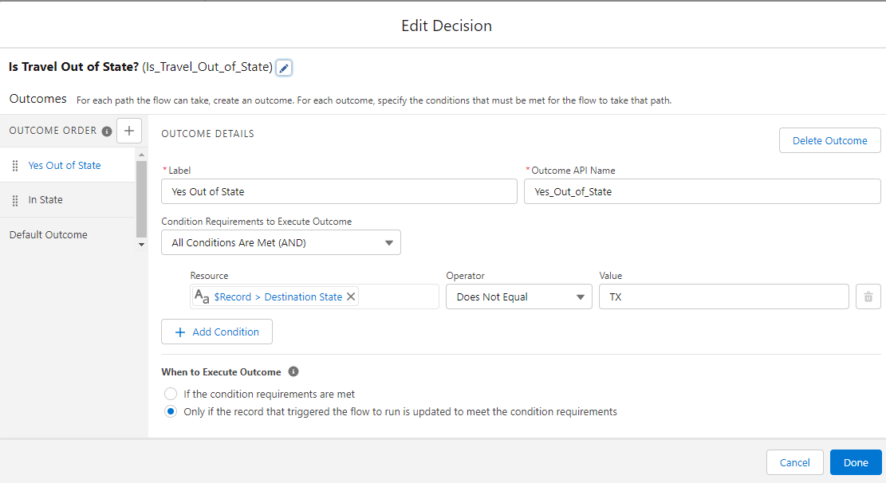

Click the + next to Outcome Order on the left to add more conditions

* Drag from the white circle on the start element to add a connector

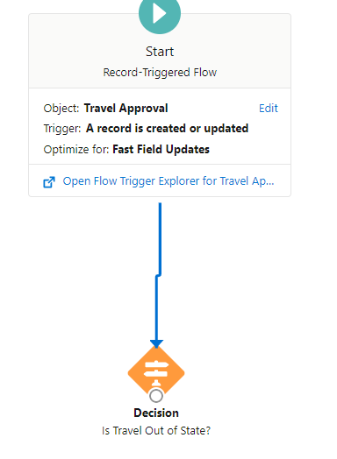

You can copy an element using this (the 2 pages icon below)

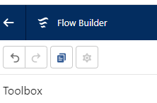

* Save and Activate

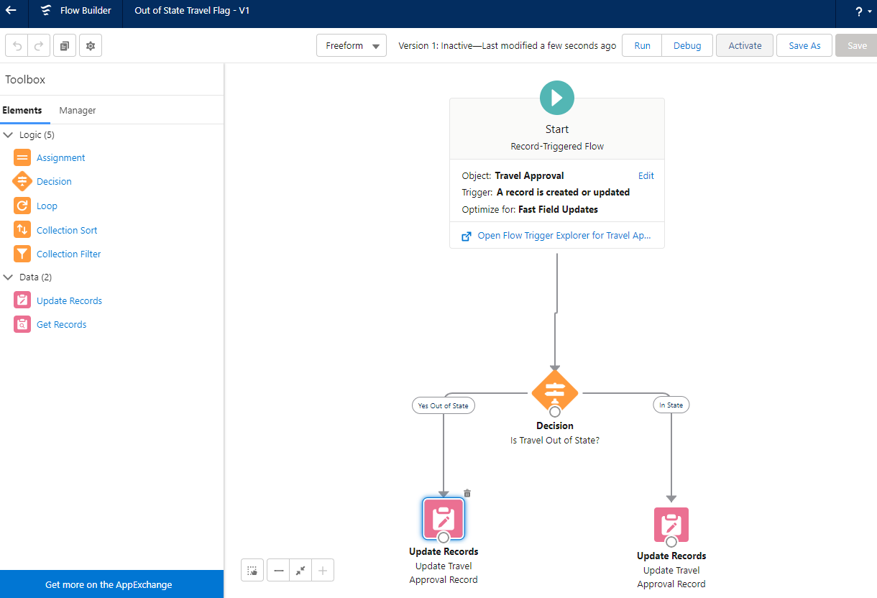

* Other Types of Process Flows:
  + Approval Processes – The course had a good walkthrough of this (not detailed here)

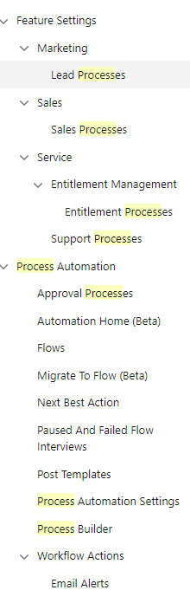

* Enable approvals via Email:
  + Setup > Process Automation Settings
  + Check the Enable email… box

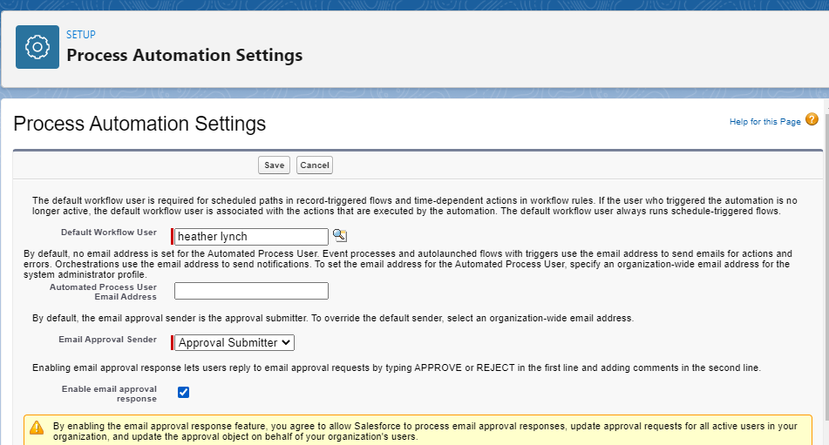

# Reports

This is pretty straightforward.

Create reports from the Reports dropdown on the object

Select columns by selecting them in the Columns pane on the left

Click the dropdown next to a field in the Report pane to Group by

To modify the way it groups, click the same dropdown (after the initial grouping) and make the desired change (below we grouped by Month instead of the individual date)

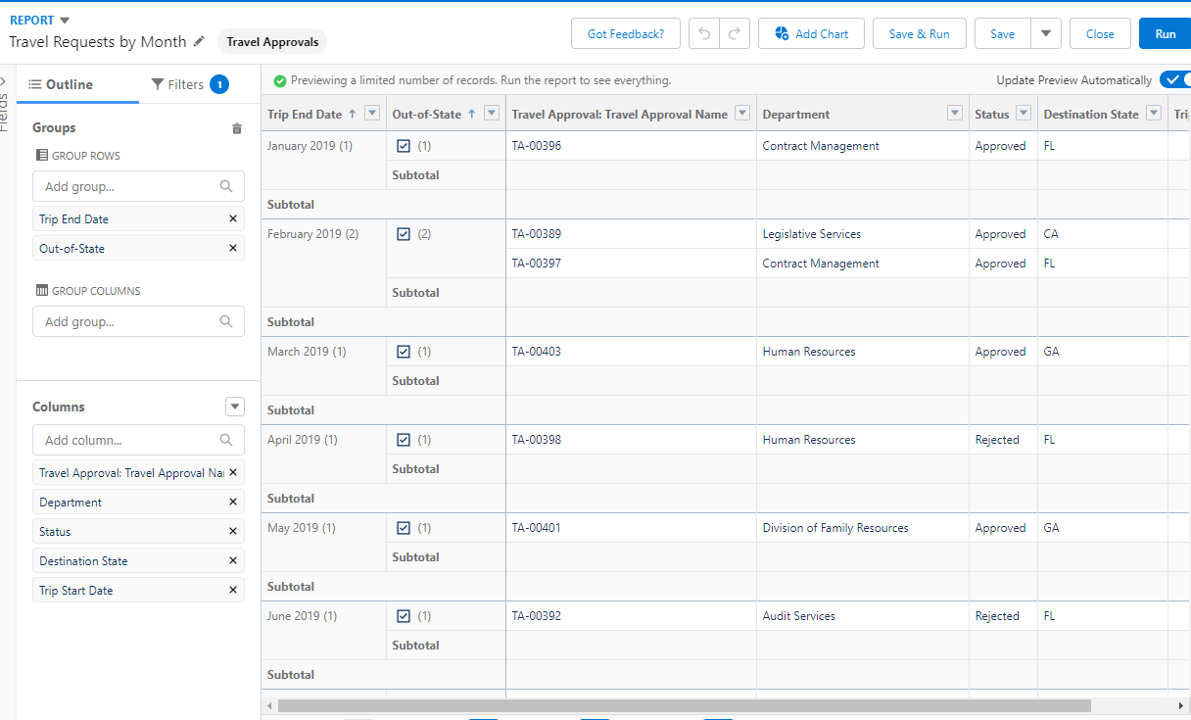

# Dashboard

Place reports on a Dashboard